KISHOR KUMAR-192311022

1. Write a program to find the reverse of a given number using recursive.

**Code:**

def rev(n,r):

if n==0:

return r

else:

return rev(n//10,r*10+n%10)

num=int(input("enter the number: "))

a=rev(num,0)

print("reverse",a)

**Screenshot for I/O:**

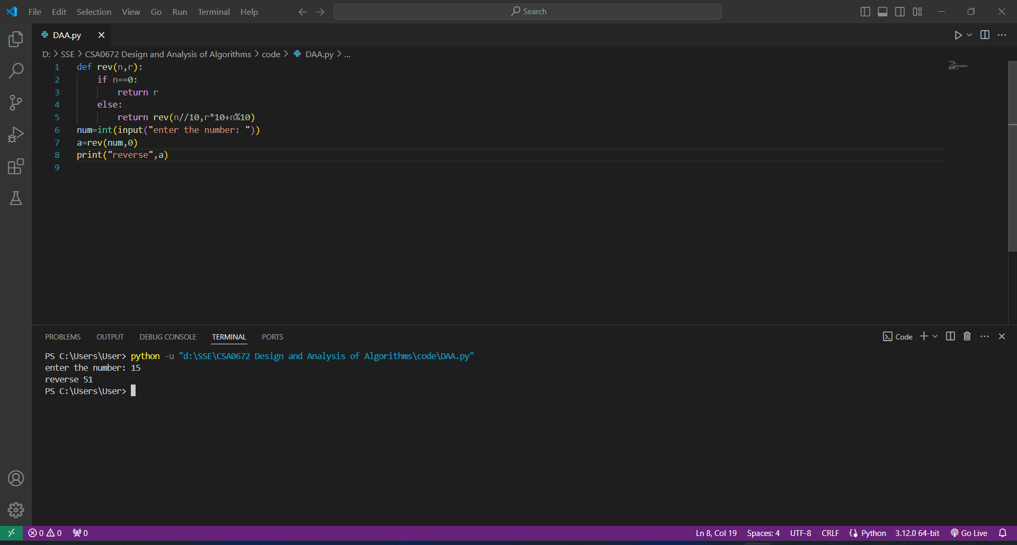

Time Complexity:O(n)

2. Write a program to find the perfect number.

**Code:**

n=int(input("enter the nummber: "))

sum=0

for i in range(1,n):

if n%i==0:

sum=sum+i

if(sum==n):

print("perfect number")

else:

print("not perfect number")

**Screenshot for I/O:**

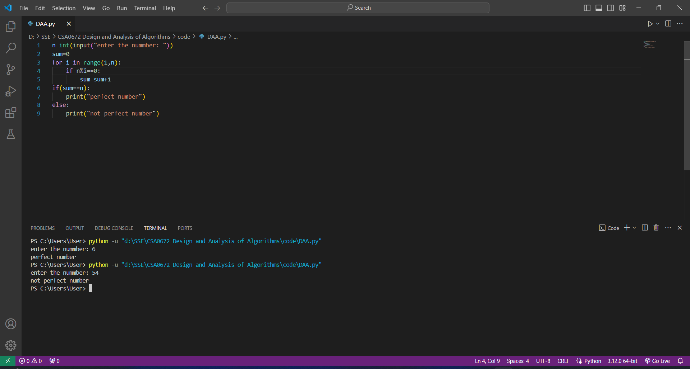

**Time Complexity:O(n)**

3. Write C program that demonstrates the usage of these notations by analyzing the time complexity of some example algorithms.

**Code:**

n=10

sum=0

#0(1) constant time complexity

sum=n*(n+1)/2

print(sum)

# 0(n) linear time complexity

for i in range(1,n):

sum+=i

print(sum)

# O(n^2) quadratic time complexity

for i in range(1,n):

for j in range(1,n):

sum+=i+j

print(sum)

**Screenshot for I/O:**

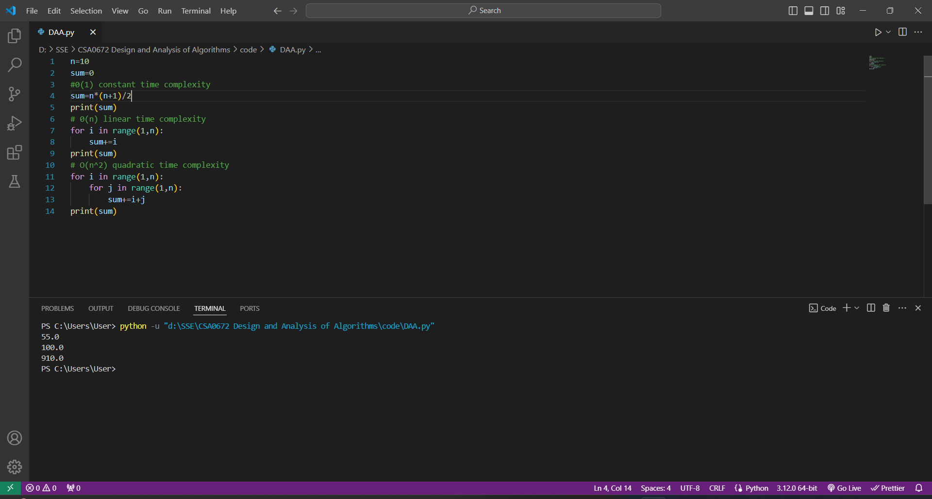

**Time Complexity: O(n^2)**

4. Write C programs that demonstrate the mathematical analysis of non-recursive and recursive algorithms.

**Code:**

def nonre(n):

sum=0

for i in range(1,n+1):

sum+=i

return sum

def re(n):

if n==0:

return 0

else:

return n+re(n-1)

n=5

print("Result of Non Recursive Algorthim:",nonre(n))

print("Result of Recursive Algorthim:",re(n))

**Screenshot for I/O:**

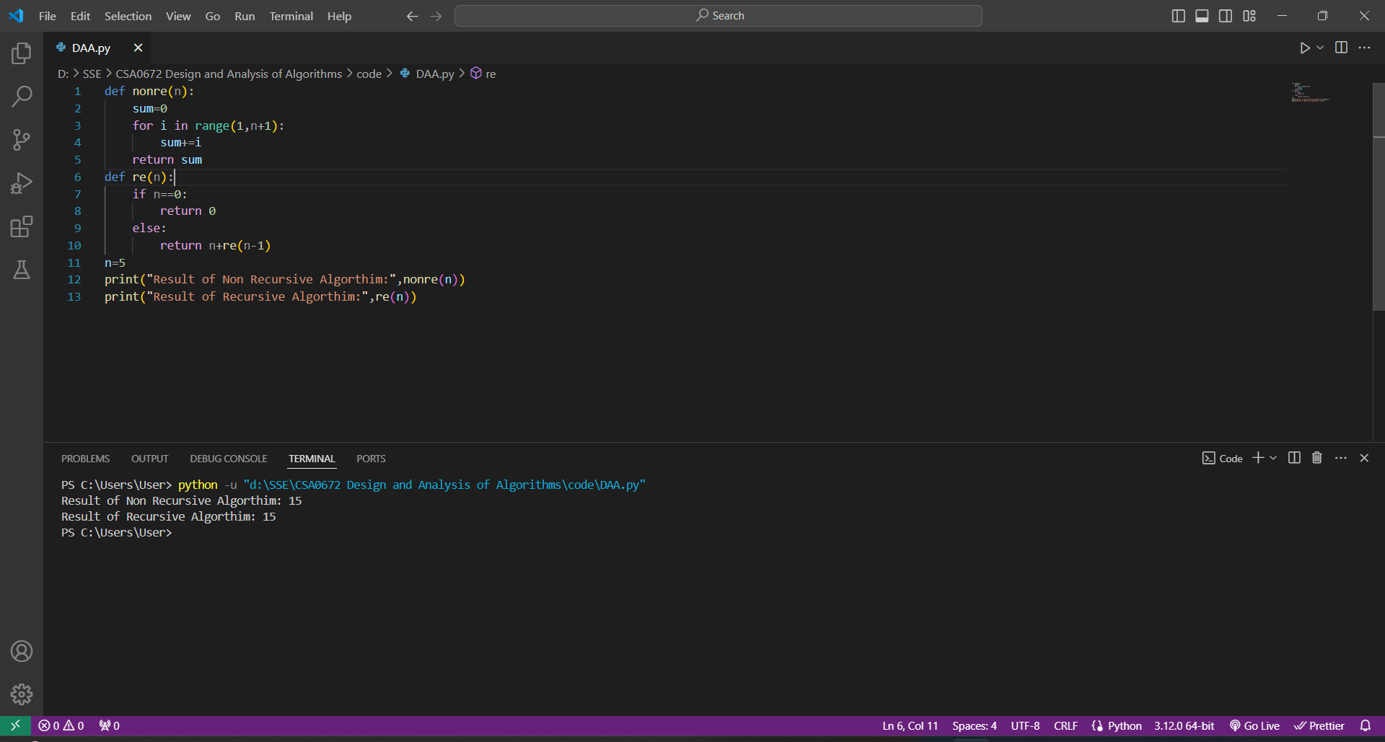

**Time Complexity: O(n)**

6. Given two integer arrays nums1 and nums2, return an array of their Intersection. Each element in the result must be unique and you may return the result in any order.

**Code:**

def inter(a,b):

return (a&b)

set1={1,2,3,4}

set2={3,4,5,6}

res=inter(set1,set2)

print(res)

**Screenshot for I/O:**

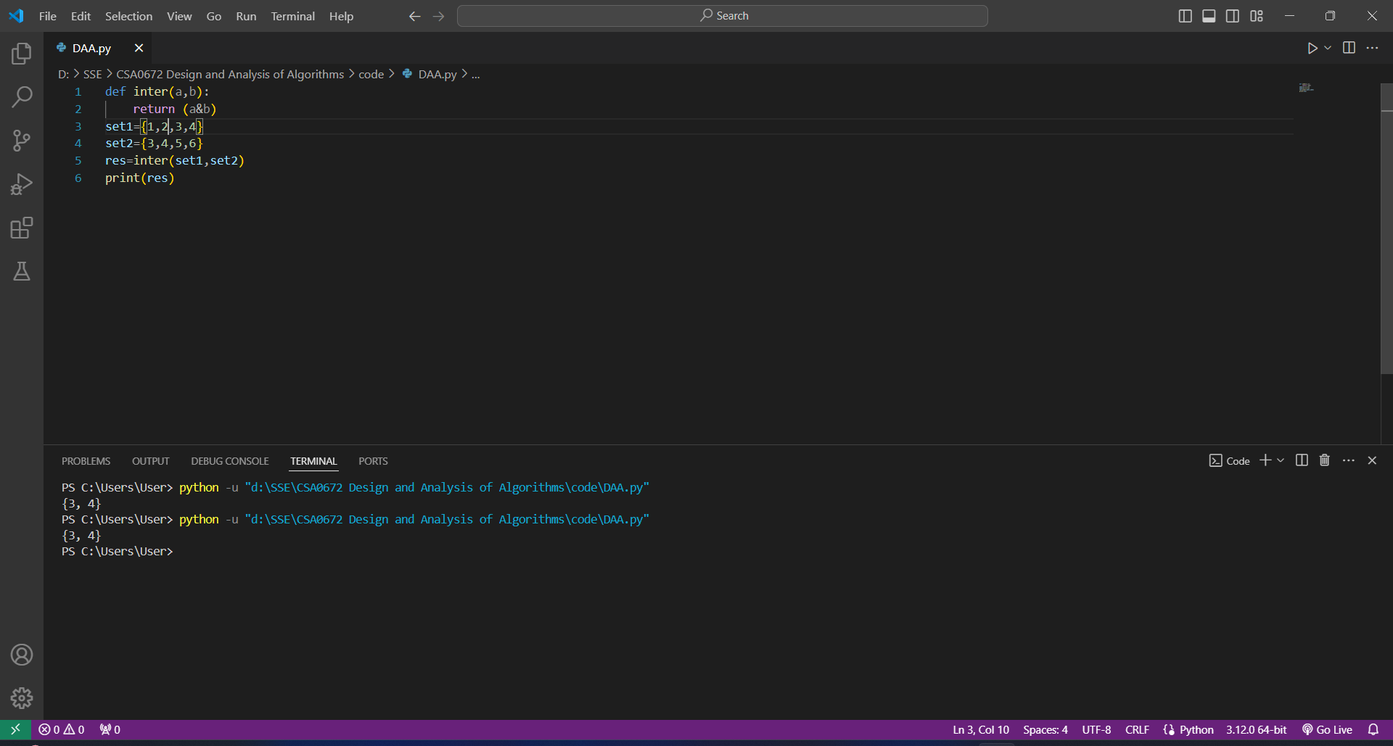

**Time Complexity: O(n)**

7. Given two integer arrays nums1 and nums2, return an array of their intersection. Each element in the result must appear as many times as it shows in both arrays and you may return the result in any order.

**Code:**

def intersect(num1,num2):

freq={}

for num in num1:

if num not in freq:

freq[num]=0

freq[num]+=1

intersection=[]

for num in num2:

if num in freq and freq[num]>0:

intersection.append(num)

freq[num]-=1

return intersection

num1=[1,2,2,1]

num2=[2,2]

inter=intersect(num1,num2)

print(inter)

**Screenshot for I/O:**

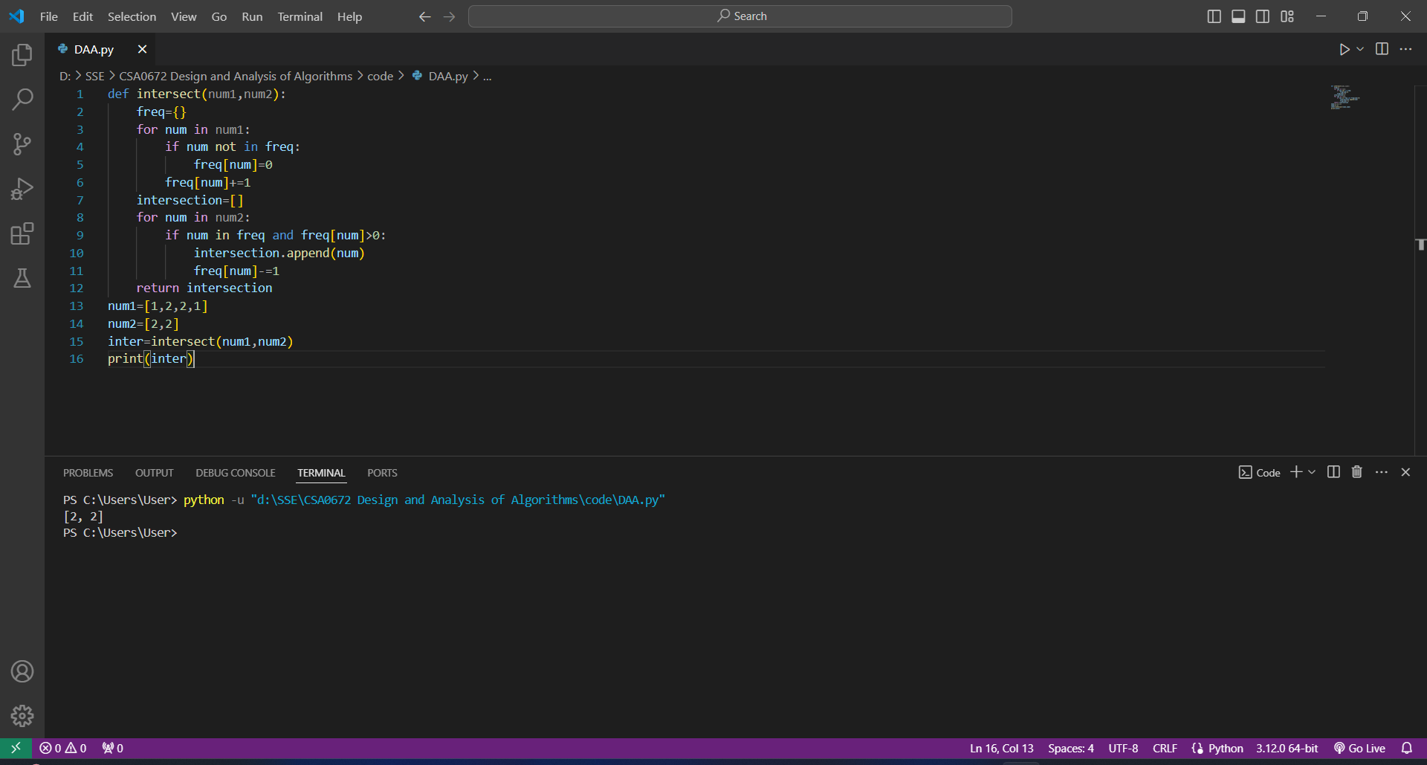

**Time Complexity: O(n*m)**

9. Given an array of integers nums, half of the integers in nums are odd, and the other half are even.

**Code:**

def sort(nums):

odd=[]

even=[]

result=[]

for num in nums:

if num%2==0:

even.append(num)

else:

odd.append(num)

for i in range(len(nums)):

if i%2==0:

result.append(even.pop())

else:

result.append(odd.pop())

return result

nums=[4,2,5,7]

sorted_nums=sort(nums)

print(sorted_nums)

**Screenshot for I/O:**

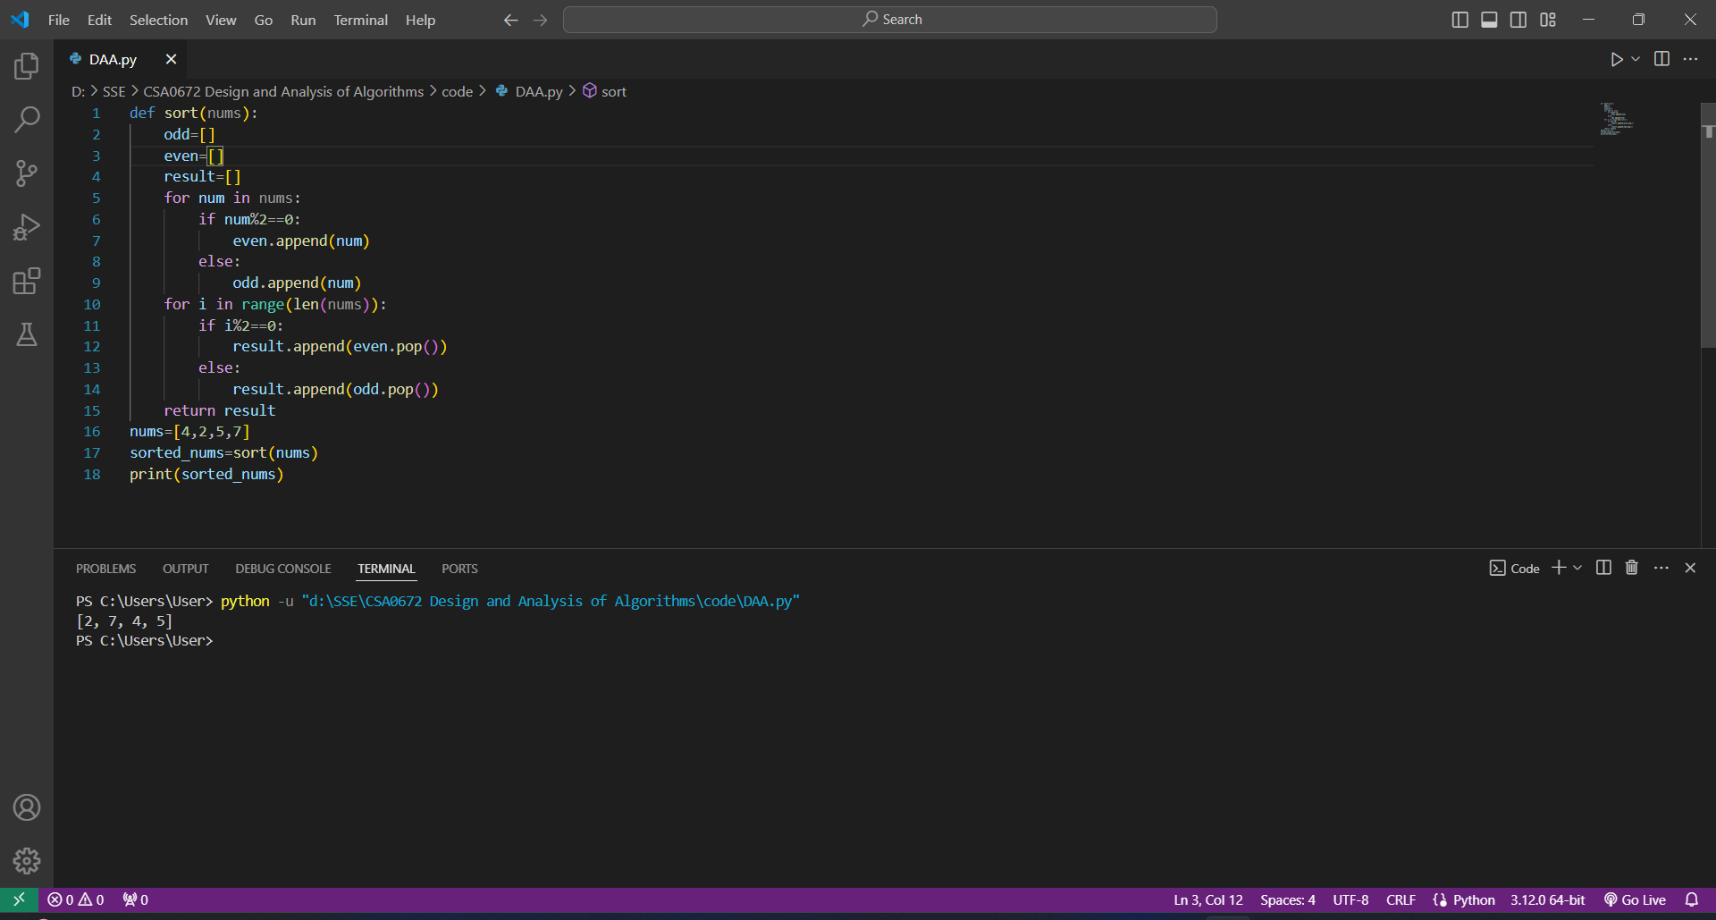

**Time Complexity: O(n*m)**